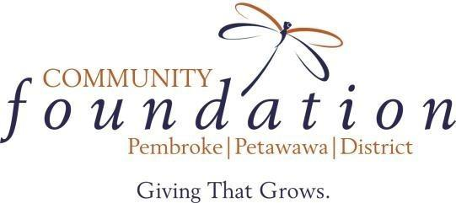

Letter of Intent: Bereavement Fund
Note: This form must be completed and accepted by the Foundation prior to submitting a formal grant application. Please submit the form to: foundation@givingthatgrows.com by March 11, 2024.

Name of Organization:
Charitable Business Number:
Organization's mission or purpose (50 words max)
Issue or community priority the project will address
(50 words max)
Concise description of the activities to be undertaken (100 words max)
Start and completion dates
Budget expenditure and revenues for the project
Amount of money requested and where it will be spent (up to $5,000 for general causes and up to $1,500 in support of bereavement)

www.givingthatgrows.com | Phone: 613-635-2256 | foundation@givingthatgrows.com

